Descritpion | Type | Longueur | Exemple | Nom_colonne | Contraintes
id_commande | N | 100 | 1 | id_cmd | Obligatoire,>=0  auto-increment
date | date | 20 | 12/10/1997 | date | Obligatoire,>0
id_ecole | N | 100 | 1 | id_ecole | Obligatoire,>=0  auto-increment
ecole | AN | 30 | Saint-vincent | ecole | Obligatoire,>0
id_utillisateur | N | 100 | 1 | id_util | Obligatoire,>=0  auto-increment
Mot de passe en crypt | AN | 60 | agrjy »é&_è »e | Mdp en crypt | Obligatoire,>0
id_ecole | N | 100 | 1 | id_ecole | Obligatoire,>==0  auto-increment
nombre_repas | N | 40 | 27 | nmbr_repas | Obligatoire,>0
id_repas | N | 100 | 1 | id_repas | Obligatoire,>=0  auto-increment
vegetarien | N | 20 | 3 | vege | Obligatoire,>=0
s_gluten | N | 20 | 3 | s_gluten | Obligatoire,>=0
s_porc | N | 20 | 3 | s_porc | Obligatoire,>=0
s_lactose | N | 20 | 3 | s_lactose | Obligatoire,>=0
id_repadif | N | 100 | 1 | id_repadif | Obligatoire,>=0  auto-increment

MCD
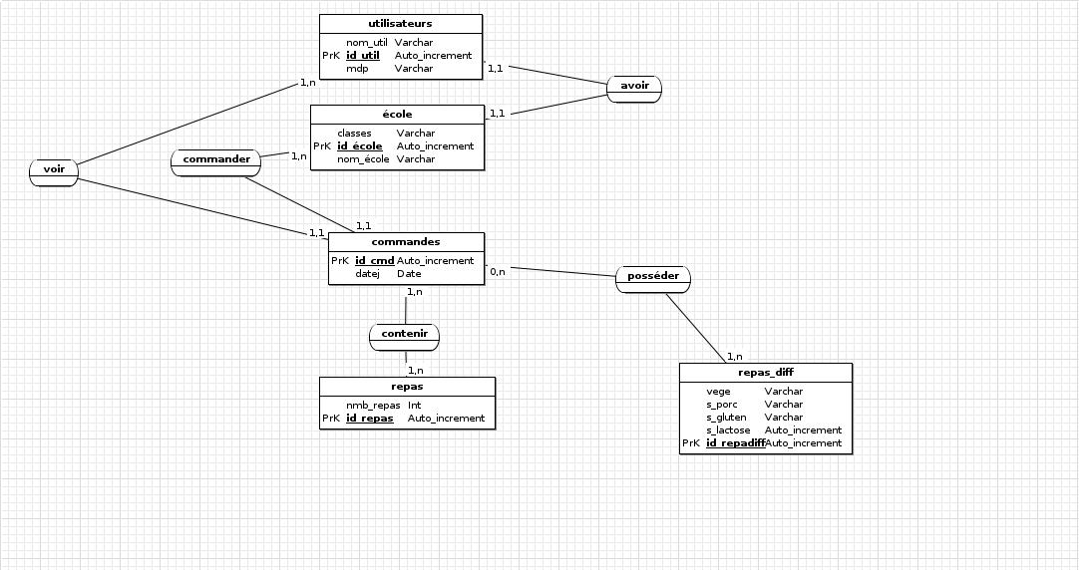

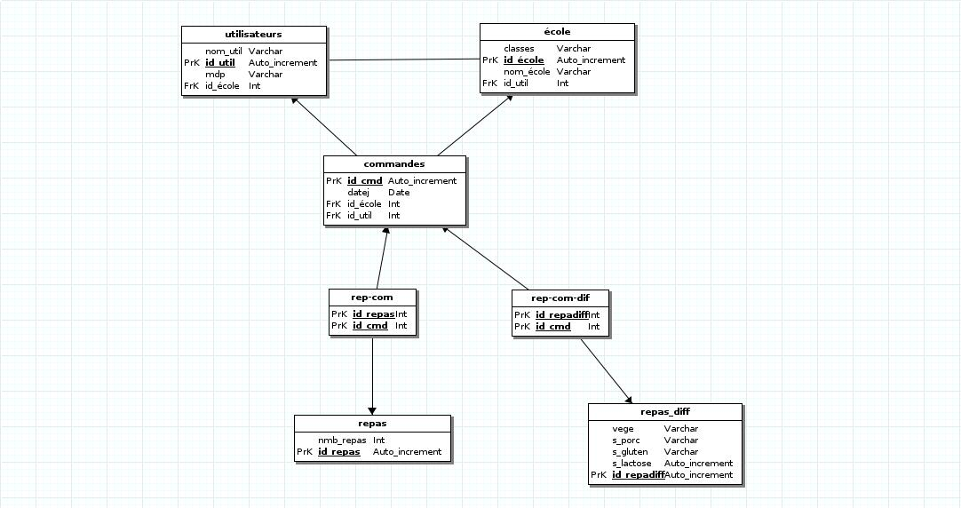
MLD

MLD
------------------------------------------------------------
-- Script Postgre
------------------------------------------------------------

------------------------------------------------------------
-- Table: repas_diff
------------------------------------------------------------
CREATE TABLE public.repas_diff(
vege VARCHAR (20) ,
s_porc VARCHAR (30) ,
s_gluten VARCHAR (30) ,
s_lactose SERIAL NOT NULL ,
id_repadiff SERIAL NOT NULL ,
CONSTRAINT prk_constraint_repas_diff PRIMARY KEY (id_repadiff)
)WITHOUT OIDS;

------------------------------------------------------------
-- Table: école
------------------------------------------------------------
CREATE TABLE public.ecole(
classes VARCHAR (10) ,
id_ecole SERIAL NOT NULL ,
nom_ecole VARCHAR (25) ,
id_util INT ,
CONSTRAINT prk_constraint_ecole PRIMARY KEY (id_ecole)
)WITHOUT OIDS;

------------------------------------------------------------
-- Table: commandes
------------------------------------------------------------
CREATE TABLE public.commandes(
id_cmd SERIAL NOT NULL ,
datej DATE ,
id_ecole INT ,
id_util INT ,
CONSTRAINT prk_constraint_commandes PRIMARY KEY (id_cmd)
)WITHOUT OIDS;

------------------------------------------------------------
-- Table: utilisateurs
------------------------------------------------------------
CREATE TABLE public.utilisateurs(
nom_util VARCHAR (60) ,
id_util SERIAL NOT NULL ,
mdp VARCHAR (60) ,
id_ecole INT ,
CONSTRAINT prk_constraint_utilisateurs PRIMARY KEY (id_util)
)WITHOUT OIDS;

------------------------------------------------------------
-- Table: repas
------------------------------------------------------------
CREATE TABLE public.repas(
nmb_repas INT ,
id_repas SERIAL NOT NULL ,
CONSTRAINT prk_constraint_repas PRIMARY KEY (id_repas)
)WITHOUT OIDS;

------------------------------------------------------------
-- Table: rep-com
------------------------------------------------------------
CREATE TABLE public.rep_com(
id_repas INT NOT NULL ,
id_cmd INT NOT NULL ,
CONSTRAINT prk_constraint_rep_com PRIMARY KEY (id_repas,id_cmd)
)WITHOUT OIDS;

------------------------------------------------------------
-- Table: rep-com-dif
------------------------------------------------------------
CREATE TABLE public.rep_com_dif(
id_repadiff INT NOT NULL ,
id_cmd INT NOT NULL ,
CONSTRAINT prk_constraint_rep_com_dif PRIMARY KEY (id_repadiff,id_cmd)
)WITHOUT OIDS;

ALTER TABLE public.ecole ADD CONSTRAINT FK_ecole_id_util FOREIGN KEY (id_util) REFERENCES public.utilisateurs(id_util);
ALTER TABLE public.commandes ADD CONSTRAINT FK_commandes_id_ecole FOREIGN KEY (id_ecole) REFERENCES public.ecole(id_ecole);
ALTER TABLE public.commandes ADD CONSTRAINT FK_commandes_id_util FOREIGN KEY (id_util) REFERENCES public.utilisateurs(id_util);
ALTER TABLE public.utilisateurs ADD CONSTRAINT FK_utilisateurs_id_ecole FOREIGN KEY (id_ecole) REFERENCES public.ecole(id_ecole);
ALTER TABLE public.rep_com ADD CONSTRAINT FK_rep_com_id_repas FOREIGN KEY (id_repas) REFERENCES public.repas(id_repas);
ALTER TABLE public.rep_com ADD CONSTRAINT FK_rep_com_id_cmd FOREIGN KEY (id_cmd) REFERENCES public.commandes(id_cmd);
ALTER TABLE public.rep_com_dif ADD CONSTRAINT FK_rep_com_dif_id_repadiff FOREIGN KEY (id_repadiff) REFERENCES public.repas_diff(id_repadiff);
ALTER TABLE public.rep_com_dif ADD CONSTRAINT FK_rep_com_dif_id_cmd FOREIGN KEY (id_cmd) REFERENCES public.commandes(id_cmd);

